www.chesapeakedock.com
7364 Edgewood Road Bldg A l Annapolis, MD 21403
Ph: 410-295-0002 Fx: 410-295-0006 e-mail: info@chesapeakedock.com

DOCK ACCESSORIES l LIGHTING SYSTEMS l CUSTOM DOCK FURNITURE l COPPER CAPPING l DOCK MAINTENANCE

WWW.chesapeakedock.com
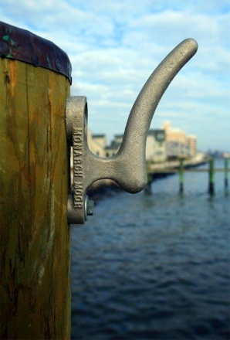

Line Mate JR
Line Mate Jr. is designed to hold your mooring lines. This unique product is also ideal for keeping dockside power lines from hanging in the water-or for water hoses so they are out of the way, so no one can trip on them. A handy aid in docking on windy days, when docking can be a problem. Use your boat hook to grab onto the Line Mate Jr. and pull boat toward dock. The Line Mate Jr. is a heavy-duty casting made of Almag 35. A composition of Aluminum for corrosion resistance and Magnesium for strength.
$41.99
Monarch Hose Holder
Made of cast Almag 35 aluminum for corrosion resistance and magnesium for strength.
Guaranteed to last! Simple to install!
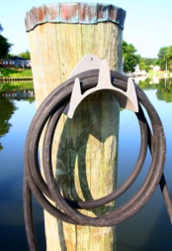
$45.99

